The Southwestern Mission Research Center (SMRC) presents:

“Northern California Missions Tour”
May 15-18, 2020
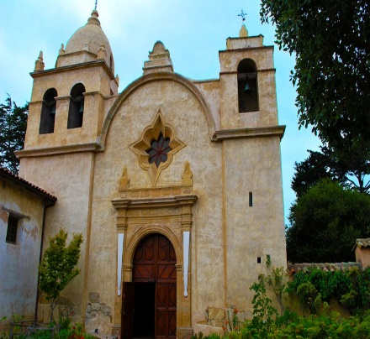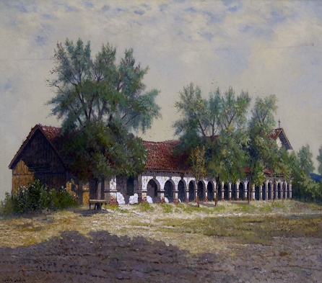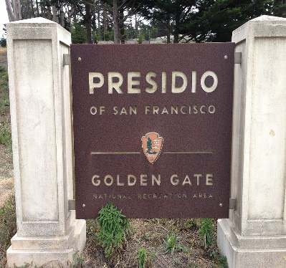

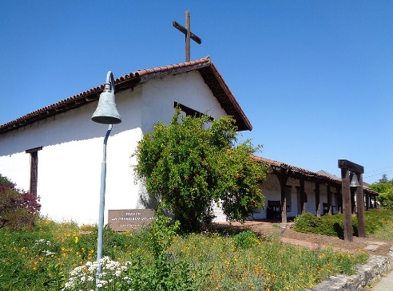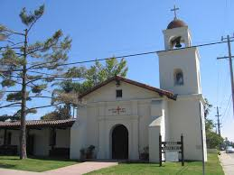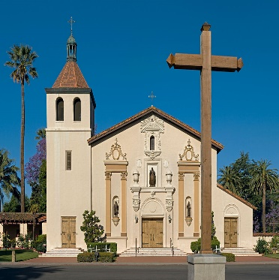

Join us for a 4-day tour of seven missions and one presidio established during the 1700s and early 1800s in Northern California. We will visit the beautiful missions of Santa Clara de Asís, San Juan Bautista, San Carlos Borromeo de Carmelo (aka Mission Carmel), Santa Cruz, San Francisco de Asís (aka Mission Dolores), San Francisco Solano (aka Sonoma Mission), San José, and one afternoon at the Presidio of San Francisco.

Guests will fly into San Jose where everyone will stay the night at a designated hotel near the airport. The next morning we will depart in the comfort of a charter bus to visit Mission Santa Clara and Mission San Juan Bautista in the afternoon, staying the night in Monterey. Day 2 will include visiting the missions of Carmel (final resting place of Fr. Serra) and Santa Cruz, spending the night in San Francisco. Day 3, we are off to visit to Mission Dolores in the morning and the Presidio of San Francisco in the afternoon. The evening will be spent in Santa Rosa. The final day will include visits to Mission San Francisco Solano and Mission San Jose. Guests will spend the night at the same hotel in San Jose we departed from on Day 1. This hotel offers complimentary airport shuttle for guests flying into and out of San Jose International Airport.

For itinerary & reservations contact Monica Young at (520) 621-6278 or mzyoung@email.arizona.edu. The cost per person for this 5-night, 4-day tour is $1,700 ($500 single supplement fee), with a $300 deposit required per person. Tour fee includes five nights accommodations, 4-day charter bus transportation, five breakfasts, four lunches, all venue fees and gratuities. Guests will pay for their travel expenses to and from San Jose and dinners. Hotels are located within walking distance of restaurants for dinner. Registration deadline is March 13, 2020 and space is limited to 20 guests – so don’t delay!

WE HOPE YOU CAN JOIN US!!!

